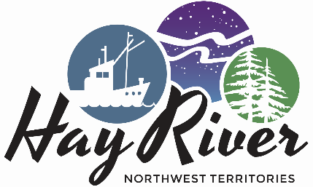

Town of Hay River
Protective Services
Town of Hay River EMO Update

May 5, 2021 Breakup Report @ 1700 Hours
Breakup continues with water levels in Northern Alberta rising slightly at Sousa Creek, and Chinchaga River has leveled off. Levels have been rising steadily on the Hay River at all monitoring stations.
Levels at Steen River are presently very high, but it looks like the rise has leveled off.
There is water flowing at the Border Station, and the breakup has occurred in that area. Levels are starting to level off.
There is water flowing over the falls with a small amount of ice at this time, and we expect to see broken ice continue to float by the camera as the breakup continues upstream. Our monitoring station is presently down, waiting for parts, but we are still keeping a close eye on levels in that area
Paradise Valley levels are remaining constant because we expect to see the breaking of the ice in that location today with an increase in levels
.
The monitoring station at Delancey Estates shows water from bank to bank, indicating that ice is starting to move closer to town.
Pine Point Bridge Monitoring station shows flow on the upstream side with ice jammed on the downstream side of the bridge. There is some cracking of the ice and break up it starting to happen on the downstream side of the bridge.
There is some cracking of Ice at the Caboose location at this time
There is a water flow above and below the ice on the West Channel and some ice is stacking down the East Channel. It appears that the water is getting to the lake on the West Channel currently
.
We will see temperatures rise over the next few days, which will increase the melt of ice and snow, and we will see levels on the Southern NWT Watershed growing more rapidly.

As breakup is now immanent locally, if you live on Vale Island or West Channel, please prepare for the possibility of an evacuation with relatively short notice.
EMO and Water Resource people are monitoring levels and will advise as things change.

Our mailing address is:
Town of Hay River Protective Services
101-62 Woodland Drive
Hay River, NT X0E1G1
Canada

